Lower North Island Rail Integrated Mobility
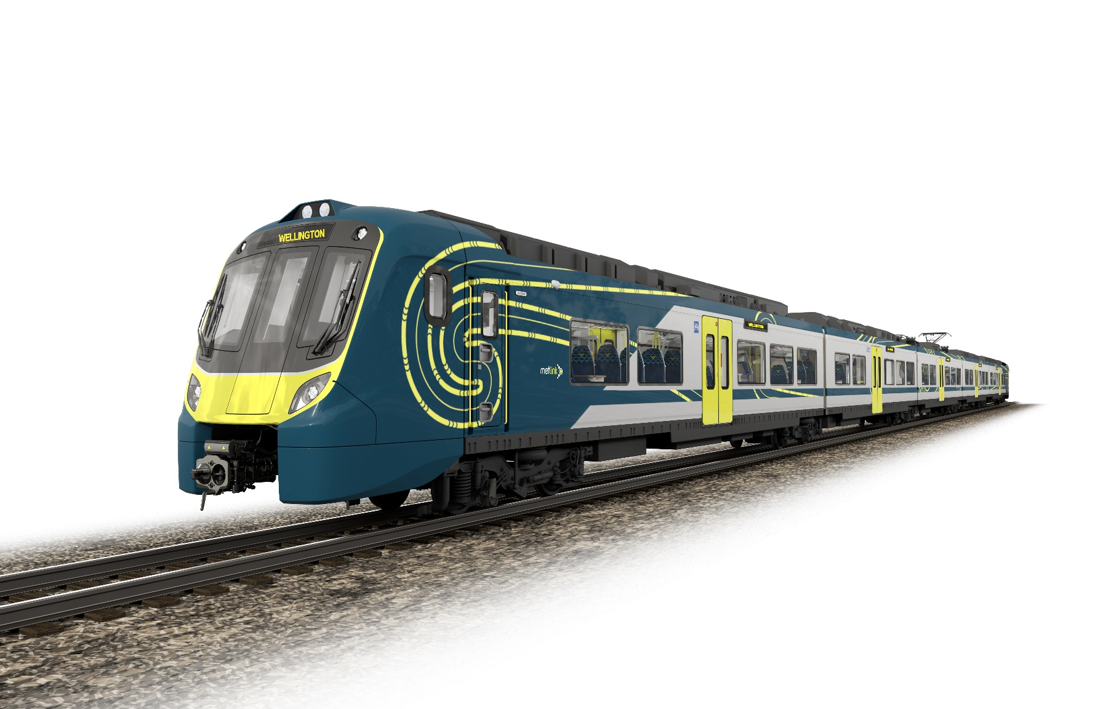
Programme Summary

Contents

1 Introduction 3

2 Train Description 5

2.1 Our new fleet - Tūhono 5

2.2 Key Tūhono Train Features 6

3 ROLLING STOCK DBM Contract Award 11

3.1 Guiding Principles 11

3.2 RFP Evaluation 12

3.3 Alstom’s Successful Proposal 12

4 Technical Description of Services 13

4.1 Rolling Stock Design and Build 13

4.2 Options for Additional BEMU’s 14

4.3 Rolling Stock Maintenance Services 14

5 Maintenance Facility 15

6 Battery Charging Infrastructure 16

7 Driver Training Simulator 16

8 Station Improvements 17

9 Delivery Schedule 18

Introduction
The Lower North Island Rail Integrated Mobility (LNIRIM) Programme will introduce a new fleet of passenger trains and increased services across the lower North Island’s Wairarapa and Manawatū Lines.
This investment will improve connectivity and access to economic, social and health opportunities through safe and reliable transport options for the communities along these corridors.
On the Wairarapa Line (between Masterton and Wellington) the programme will double peak services (from the current 3 peak each morning and evening, to 6 peak services). On the Manawatū Line (between Palmerston North and Wellington) the peak services will also be doubled (from the current 1 peak service each morning and evening, to 2 peak services). The daytime inter-peak and weekend Rail Passenger Services will also be increased across both lines.
To enable this transformative change in public transport across the lower North Island the programme is set to deliver:
- 18 Battery Electric Multiple Units (BEMU) (trains)
- A driving simulator representing the new trains to educate and train drivers
- A new BEMU maintenance facility at Masterton
- Battery charging facilities at Masterton and Palmerston North
- Expanded stabling yards at Masterton and Palmerston North
- Improved stations and platforms along both routes
- Improved operational facilities at Masterton and Palmerston North
- Passing loop improvements to enable crossing with freight trains
The programme is led by Greater Wellington Regional Council and co-delivered with KiwiRail.
The programme is funded by the Crown, Waka Kotahi, Greater Wellington Regional Council (GWRC), and Horizons Regional Council.
This programme will contribute to the following key outcomes for the lower North Island:
- Improved access and economic prosperity for Manawatū and Wairarapa regions via enhanced regional connectivity
- Economic growth by enabling implementation of regional land use plans
- Improved transport network resilience and safety
- Decarbonisation of transport networks through:
- Encouraging mode shift from private motor vehicles to rail
- Eliminating diesel-powered locomotives and generators that currently haul and power regional passenger services on these lines
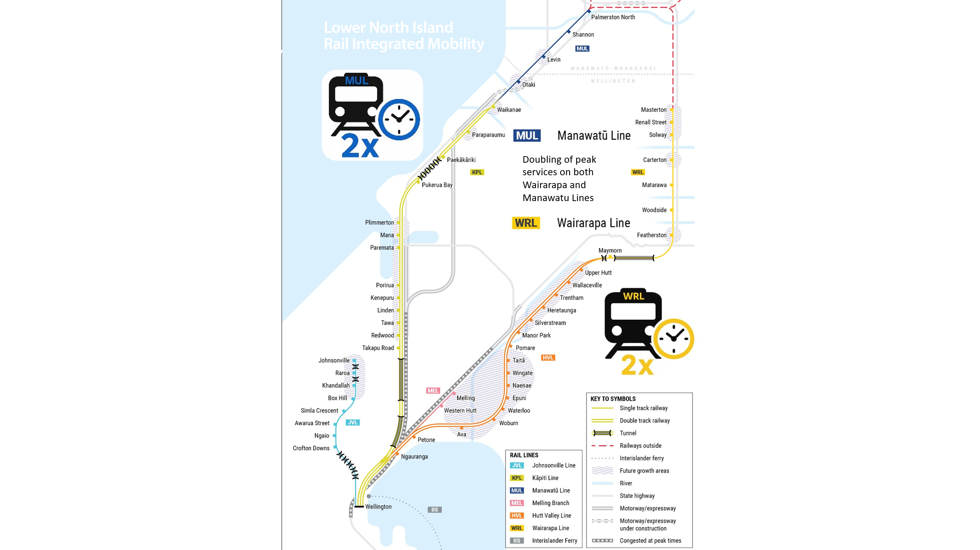

Train Description

Our new fleet - Tūhono
Greater Wellington and Horizons Regional Councils are proud to bestow the name Tūhono upon the new fleet. Tūhono, meaning “to connect” or “to unite,” is a fitting name for these trains as they symbolise regional connection and improved access for the communities they serve.
Tūhono tells the story of a train that is more than just a mode of transport — it is a living thread that weaves together the diverse communities of the lower North Island.
From urban Wellington to the rural valleys of Wairarapa, and the heartlands of Horowhenua and Manawatū, this name reflects the human and cultural connections that the service fosters.
- It speaks to whanaungatanga — the building of relationships and kinship.
- It reflects the shared aspirations of iwi, the Crown, Greater Wellington Regional Council and Horizons Regional Council, and the communities for a more connected, sustainable future.
- It acknowledges the mana of place and the people who live along the route.
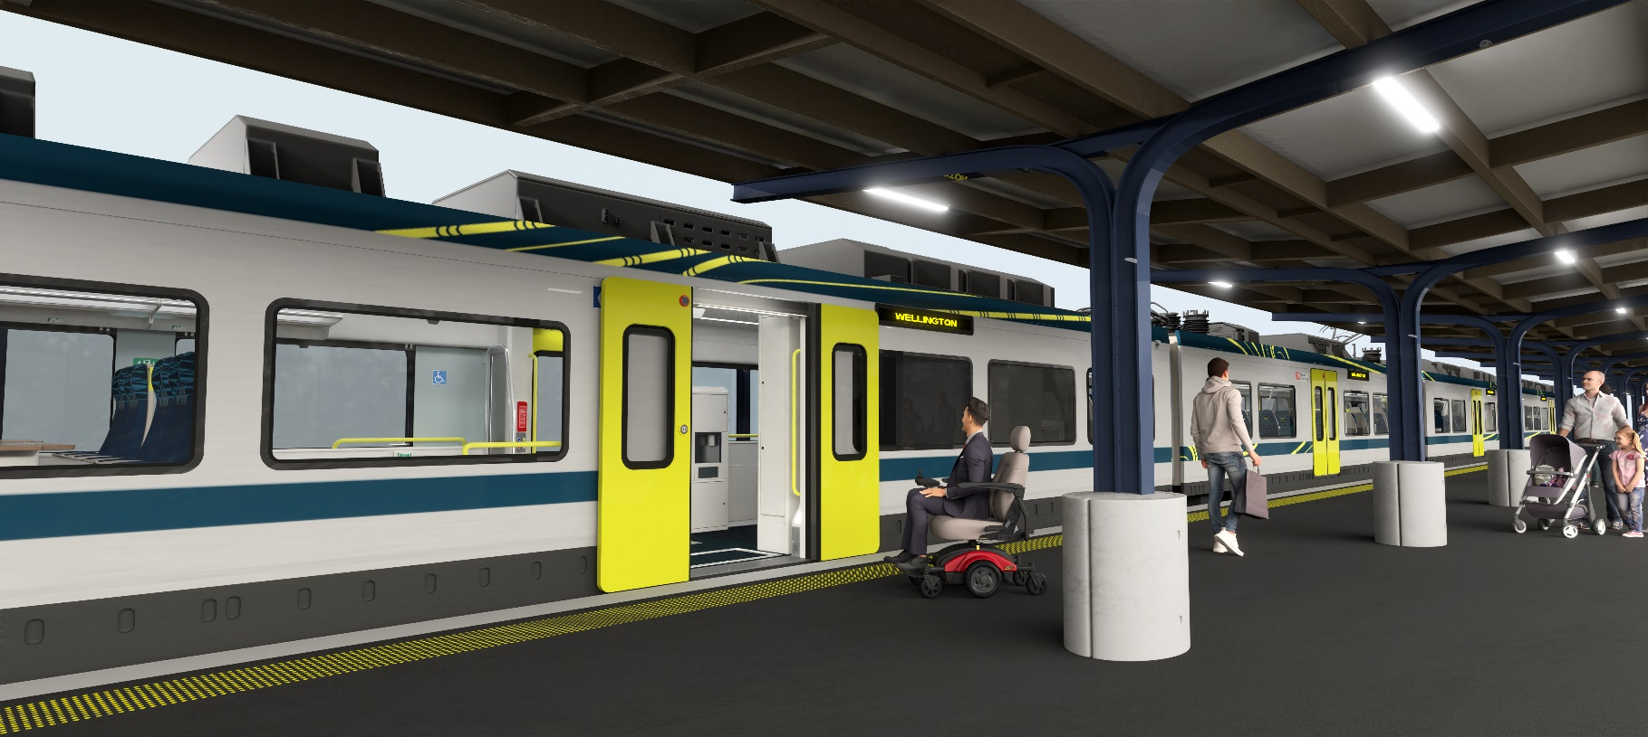

Key Tūhono Train Features
Battery traction power. Tūhono is a Battery Electric Multiple Unit (BEMU) designed specifically for the lower North Island. These trains can operate on the 1500v DC Wellington electrified network, and switch seamlessly to battery power beyond the electrified area, reaching speeds of up to 110 km/h.
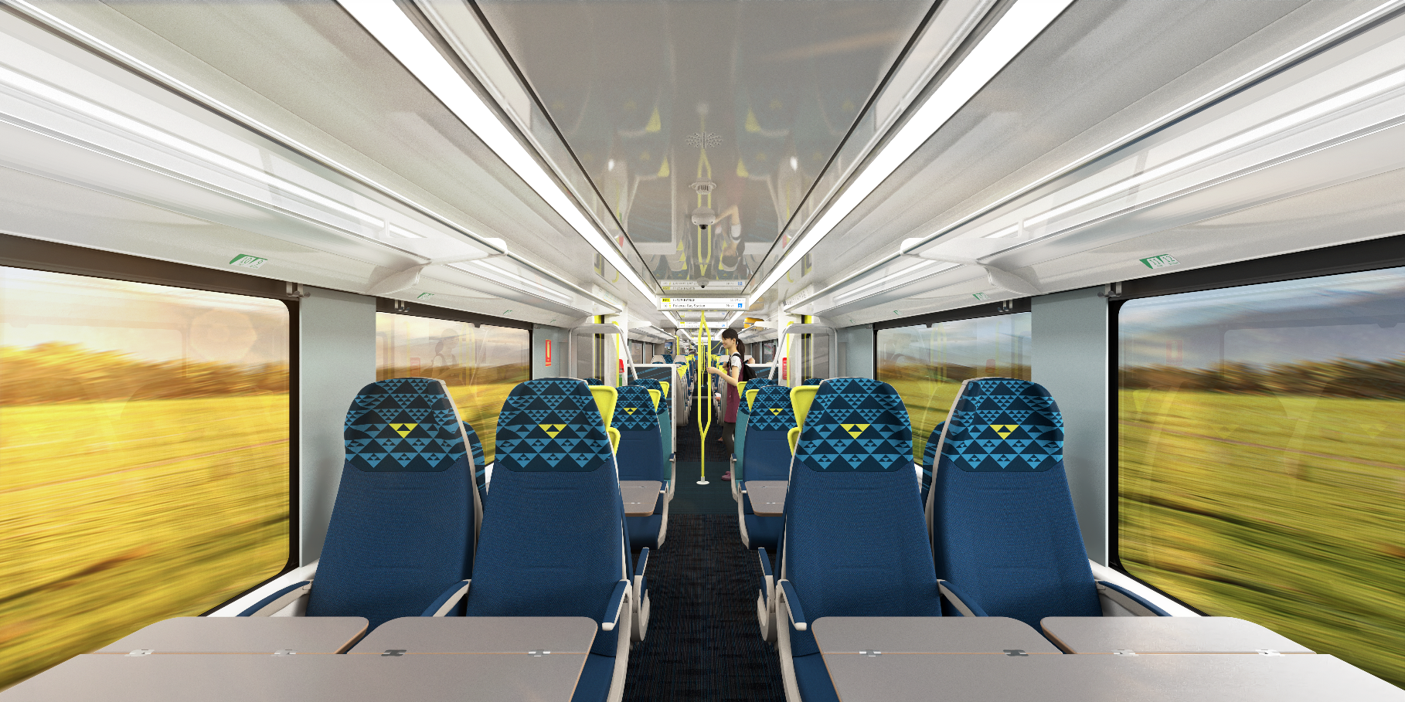
As the first battery-electric trains in the Southern Hemisphere, they incorporate advanced battery charging and regenerative braking systems to enhance energy efficiency and operational flexibility. With lightweight aluminium car bodies and fewer bogies than conventional trains, Tūhono has been purpose-built for greater efficiency and reduced environmental impact.

Capacity: Each Tūhono BEMU has seating capacity for 220 passengers with up to a further 255 passengers standing, for a total maximum capacity of 475 passengers. Tūhono can be operated in a double-unit configuration offering seating for 440 passengers per train.

Comfort. The five-car configuration is designed to prioritise fluidity, passenger comfort and interaction, making it a truly user-friendly option for all travellers. With a high number of bay seats equipped with tables, it caters to groups and families, while quieter airline style seating spaces are ideal for commuters seeking a peaceful environment. The culturally resonant interior designs feature durable materials, adaptive lighting, and inspiration from Te Ao Māori and our regions unique landscapes.
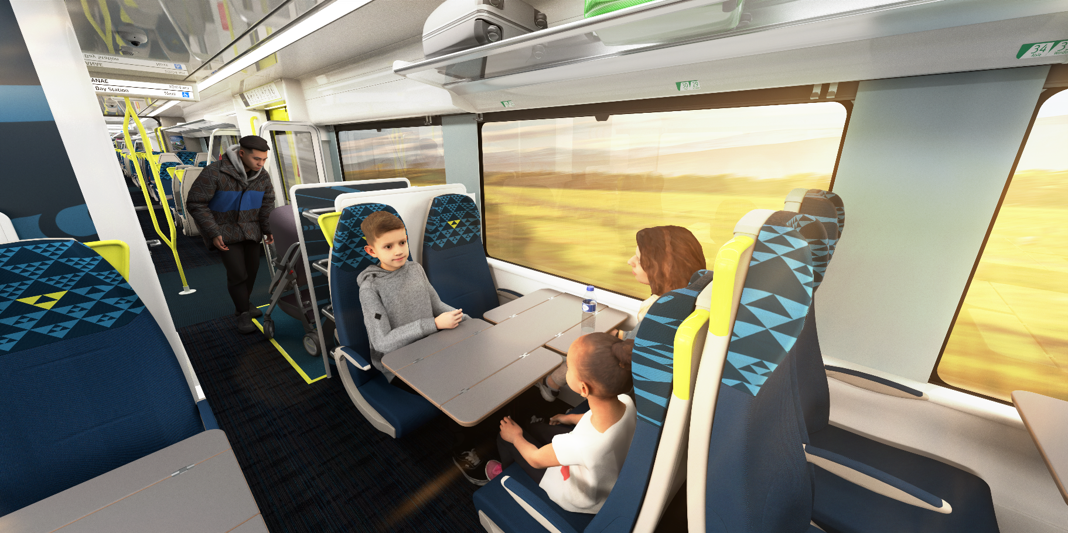
There are two toilets within each Tūhono BEMU, one of which is wheelchair accessible. Each train will also have a vending machine for snacks and freshwater dispenser.

Safety & Security. Tūhono will comply with modern safety standards and include advanced crash-worthiness features to protect crew and passengers in case of collision or derailment.
Tūhono will be fitted with CCTV cameras inside and out, as well as passenger help points for added safety and security. The open gangways between the vehicles mean that train staff will be able to quickly assist passengers and carry out their duties.

Inclusivity. The Tūhono train is designed with inclusivity in mind, featuring dedicated areas for passengers with limited mobility, including wheelchair users. These large, marked spaces are clearly distinguished by a different colour, and doors are equipped with high-contrast markings and international symbols for accessibility, ensuring they are easily identifiable.
Tūhono features easy passenger navigation with ample natural lighting, an intuitive layout, large vestibules, and clear digital displays to enhance passenger comfort and wayfinding
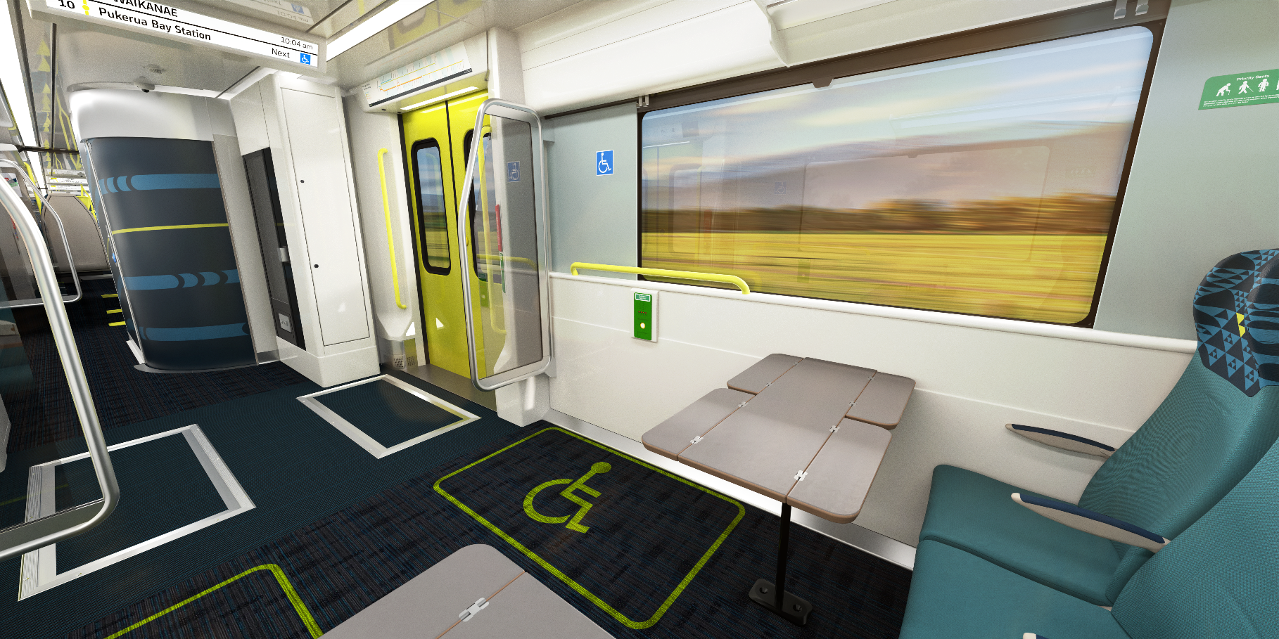

Accessibility. Each five-car Tūhono BEMU consists of two driving cab vehicles, and three intermediate vehicles. All intermediate vehicles have near level boarding access with a sliding step at each door for safe and accessible boarding.

Flexibility. Large open flexible areas are strategically distributed throughout the train. These spaces facilitate passengers with varying needs, including:
  - cyclists with bikes
  - parents with prams
  - travellers with bulky luggage
This arrangement promotes a sense of community and ensures passengers can travel with their belongings near them, enhancing the overall travel experience.
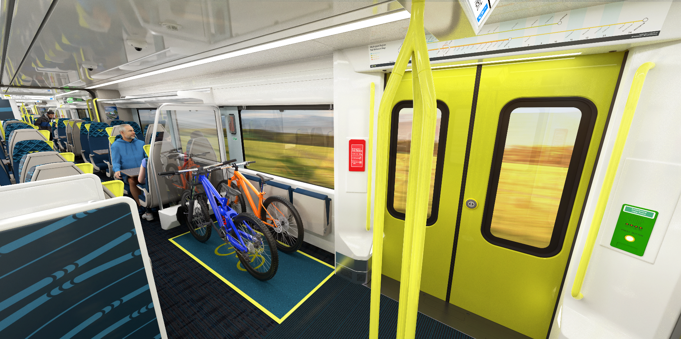

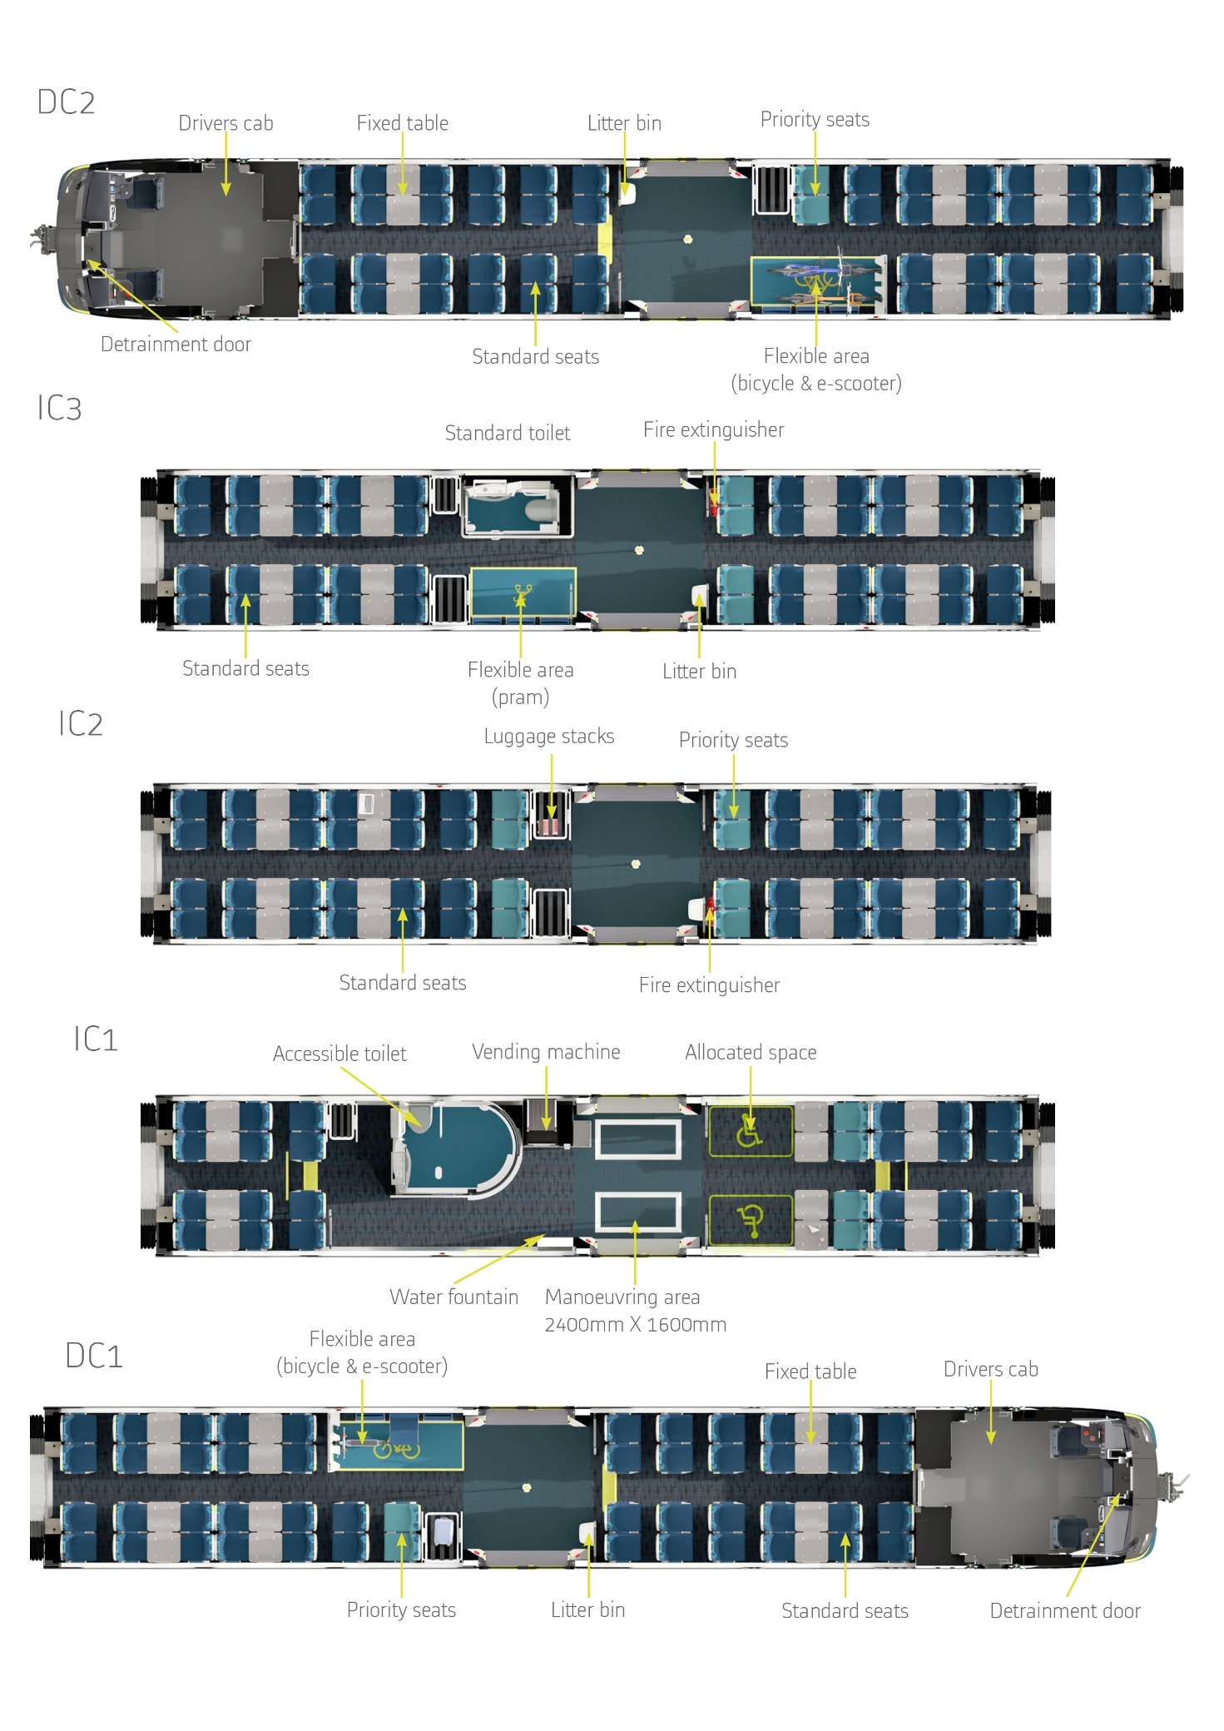

ROLLING STOCK DBM Contract Award

On 8 September 2025, Greater Wellington Regional Council, and its wholly owned Council Controlled Organisation Greater Wellington Rail Limited, as the asset owner, entered into a Design-Build-Maintenance (DBM) agreement with Alstom Rail Transportation New Zealand Limited (Alstom), to supply 18 new five-car Battery Electric Multiple Units (BEMUs) and undertake full maintenance services for the trains entire 35-year life.
This contract was awarded to Alstom after undertaking a two-stage global procurement process. This consisted of an Expression of Interest phase which resulted in a short list of three respondents. GWRC subsequently ran an interactive Request for Proposal phase with the three shortlisted respondents.
Tender Process Schedule
Procurement Milestones | Key Dates
Release of Expression of Interest (EOI) | 13 December 2023
Close of Expression of Interest (EOI) | 21 February 2024
Announcement of shortlisted respondents:  - Alstom Rail Transportation New Zealand Limited (Alstom)  - Construcciones y Auxiliar de Ferrocarriles S.A. (CAF)  - Stadler Bussnang AG. (Stadler) | 25 July 2025
Release of Request for Proposal (RFP) | 29 July 2024
Close of Request for Proposal (RFP) | 16 December 2024
Contract Award to Alstom Rail Transportation New Zealand | 8 September 2025

Guiding Principles
Within it’s Request for Proposal, GWRC outlined a set of guiding principles as a critical reference point in all decision-making, which required a fleet that delivered the following objectives:
- Trains that meet customer demand, operational efficiency, frequency of service, reliability and dependability, and operational resilience;
- Trains that can support expected growth, but in regional levels of style and comfort;
- an interior design and layout that will support the multiple functions of the intended operation ranging from shorter distance commuting to long-distance business and leisure travel, is inclusive for all customer demographics, provides an attractive passenger experience for all and reduces access barriers to travel;
- Trains that provide high levels of reliability and availability, to ensure consistent delivery of service while featuring the capability to minimise the effect on customer experience in the event of a loss of external power supply;
- Trains that achieve performance levels that are complementary to the existing Matangi fleet to aid in timetable planning;

- Trains that are designed to achieve the passenger, operational, technical and environmental requirements within which they will operate;
- use of the latest technology to improve passenger information and connectivity and provide real-time data updates for rapid service recovery;
- innovative and robust solutions for operation on sections of the Network that are not electrified; and
- cost-effective solution that minimises whole of life cost

RFP Evaluation
GWRC received compliant tenders from all three shortlisted respondents as well as one alternative proposal. As specified in the RFP Evaluation Plan the evaluation of the proposals was based on the New Zealand Transport Agency’s Price Quality Evaluation methodology without disclosure of the price.
The evaluation methodology determined that Alstom’s proposal provided the best overall value for money.

Alstom’s Successful Proposal
Alstom’s proposal comprises Battery Electric Multiple Units which will operate on onboard batteries beyond the electrified network, while using existing overhead electrification within the Wellington electrified network. The onboard batteries will be charged via fast chargers (or slow chargers overnight) at the terminal stations in Masterton and Palmerston North.
The trains are based on Alstom’s service proven X’trapolis train product and are adapted for New Zealand requirements. The trains will be similar to the Irish Rail Dart+ train which is currently undergoing commissioning in Ireland.
Alstom is a global rolling stock manufacturer and maintainer, with a significant presence in Australia. The trains will be assembled in their manufacturing facility in Savli, India, with a global supply chain –potentially including New Zealand suppliers.
The Design, Build, and Maintain contract aims to use a lifecycle approach to asset management and have a single point of responsibility. The contract is performance based incentivising Alstom to ensure trains are available, reliable, and fully functional.
The total contract value for the design, manufacture and supply of Tūhono fleet, and a 35-year maintenance contract is NZD $1,066m.

Technical Description of Services

Rolling Stock Design and Build
Alstom have developed an innovative and cost-effective Battery Electric Multiple Unit solution, based on their service proven X’trapolis train platform. The Tūhono BEMU is a lightweight 5-car unit with a semi-articulated bogie configuration.
This modern, diesel-free and lightweight solution will be tailored to the needs of the lower North Island’s outer-suburban and regional passengers.
The Tūhono train will be largely based on the Irish Rail DART+ Battery Electric Multiple Unit with the following key differences:
    - Adaptations to suit New Zealand’s narrow-gauge track
    - Front detrainment door for evacuation in single bore tunnels
    - Arrangement of Driver’s cab and crashworthiness features to suit New Zealand rail network requirements
    - Additional battery capacity
    - Regional seating configuration, including standard and universal toilets, food and drink vending machines and fresh water dispensers.
    - Low floor areas for accessible near-level boarding in intermediate cars
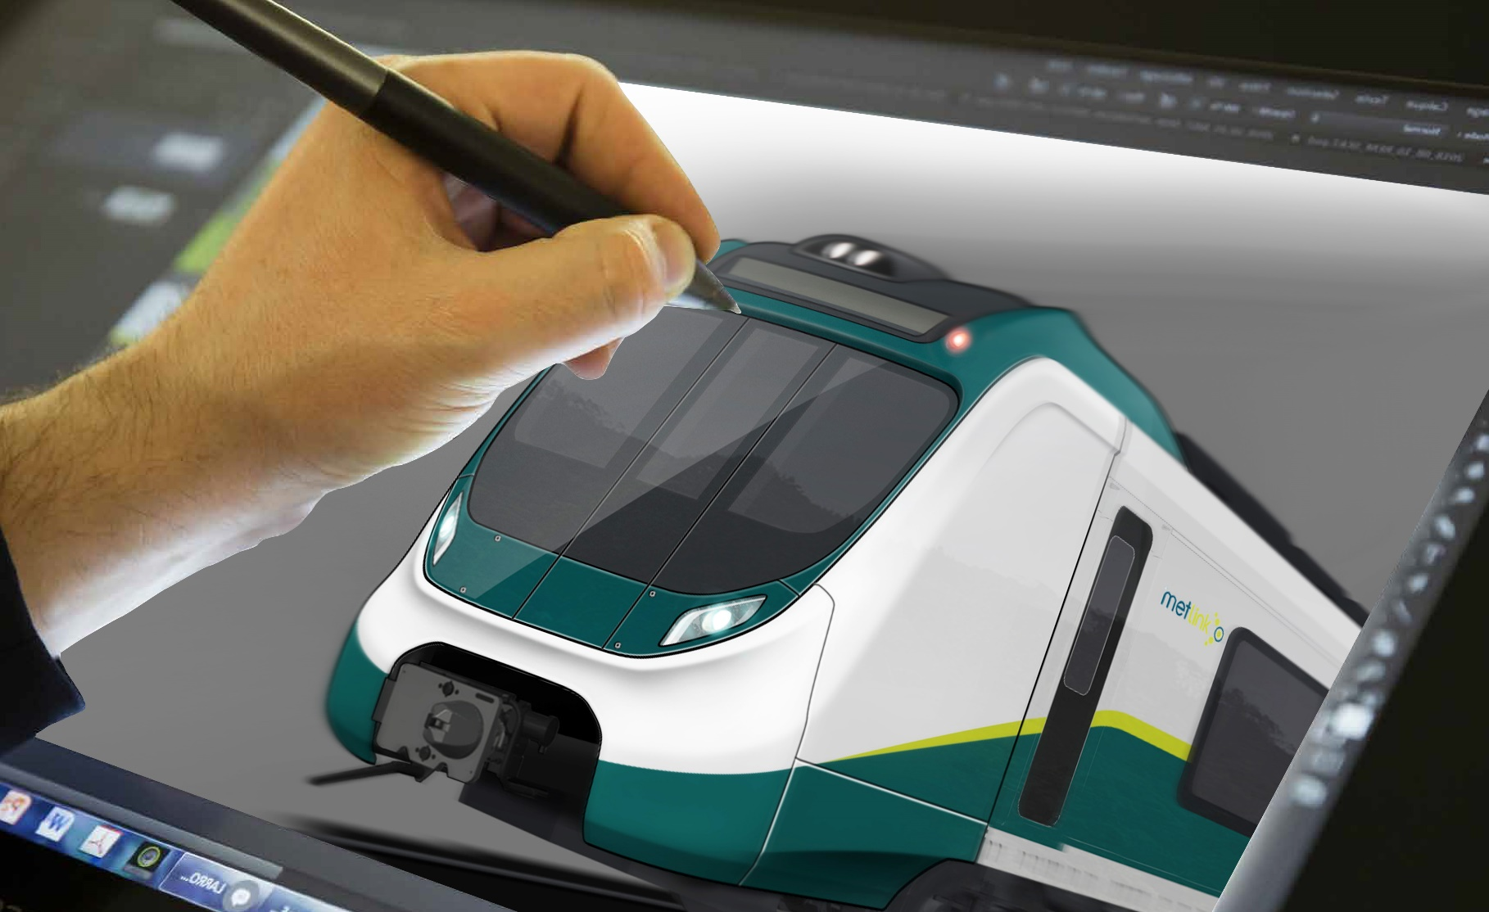
    - Culturally resonant interior and exterior design

Options for Additional BEMU’s
The agreement reached with Alstom means that GWRC have pre-priced options available to enable the following potential key changes to the contract:
- the installation of European Train Control System (ETCS) in the units,
- additional trains,
- Metro-specific variants.
The agreement also enables other New Zealand public transport authorities to enter into negotiations with Alstom for suitable BEMU’s to suit their needs.

Rolling Stock Maintenance Services
GWRC has reached an agreement with Alstom for maintenance of the rolling stock which will run for up to 35 years.
Core maintenance activities will be performed at a new purpose-built maintenance facility in Masterton. Alstom’s maintenance business will create around 30 full-time jobs. Alstom’s “Local First Strategy” will recruit, train and develop a highly skilled local workforce to support the high-tech Tūhono trains.
The Tūhono trains will be designed for ease of cleaning, efficient maintenance, and reliable operation. The maintenance services secured through this procurement will ensure all assets remain fit for purpose throughout their design life. The regime incentivises reliability improvements while maintaining high availability and full functionality in service, supported by a gain-share mechanism to drive continuous improvement and cost savings. Cleaning services will meet strict standards, with defined timeframes and output requirements to ensure consistent presentation and hygiene.
Alstom will deploy its HealthHub system to support the maintenance operation. This real-time monitoring system not only enables immediate fault detection but also provides valuable insights into failure patterns, supporting proactive maintenance and reducing the likelihood of repeat issues.

Maintenance Facility
Greater Wellington will be building a new maintenance facility in the rail yards in Masterton, to enable maintenance of the Tūhono fleet over their 35-year life.
The 4000m² maintenance facility will include facilities for the complete provision of maintenance services from routine maintenance checks to heavy maintenance overhauls. The layout will include three maintenance roads including two “swimming pool” roads with roof access platforms, and a heavy lift road designed for bogie replacement. Designed to accommodate around 30 staff the facility will include parts storage, offices, meeting rooms, kitchen and changing room facilities.
Material storage will be largely off-site with Alstom committed to providing local off-site warehousing.
A procurement to undertake the detail design and construction of this maintenance facility is expected to be released in September 2025.
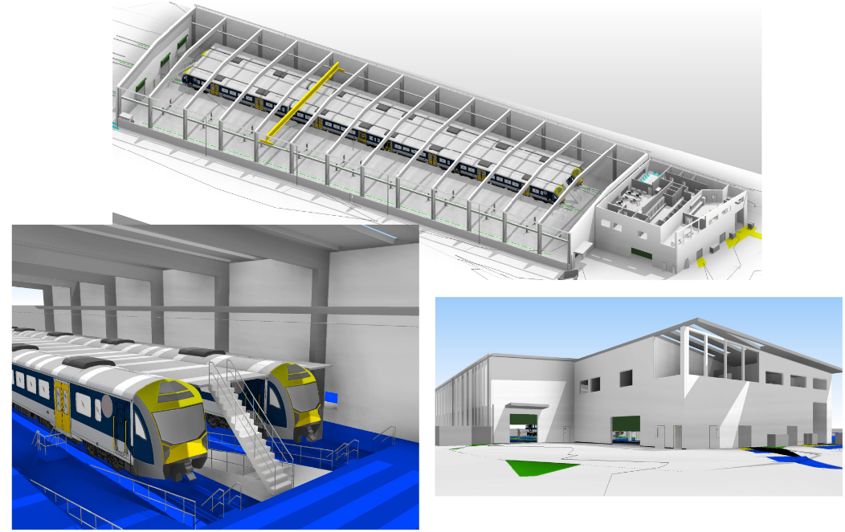

Battery Charging Infrastructure
The Tūhono trains will provide daily return services across both the Palmerston North–Wellington and Masterton–Wellington routes. After traversing the non-electrified sections beyond Waikanae or Upper Hutt, the units will use fast-charging facilities at the terminus stations before returning to Wellington. Fast charging can be completed in less than 20 minutes.
Each evening the Tūhono trains will return to stabling facilities in Palmerston North and Masterton where they will be slow-charged overnight before entering service the following morning.
Battery charging infrastructure will be procured separately from the rolling stock contract.

Driver Training Simulator
A driver training simulator will be built that is designed to immerse trainee drivers in a simulated environment to support safe and efficient driver training. The simulator is being procured directly from a simulator specialist.
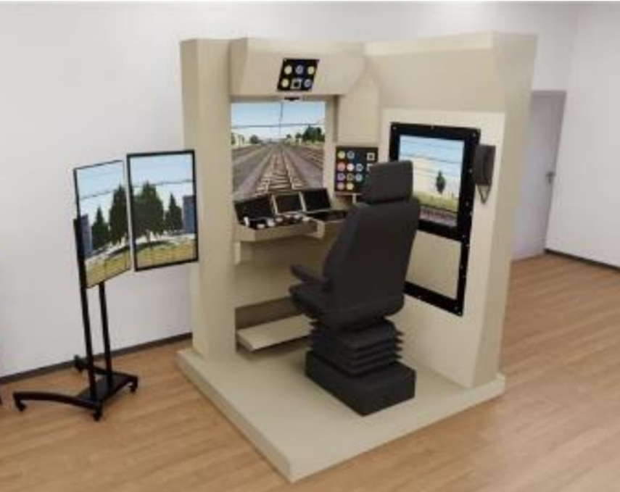
The simulator will physically replicate the Tūhono driving cab controls and interfaces and its train model will match the performance of the real train. The full lower North Island rail network will be modelled in Computer-Generated Imagery (CGI) within the simulator. This ensures drivers can gain experience and knowledge across the full network, including signalling, critical landmarks, and risk-prone areas, while developing the ability to manage safety and incidents effectively through emergency procedure training, incident protocols, and communication with control and maintenance teams.

Station Improvements

It is planned to bring all of the stations (Ōtaki, Levin, Shannon, and Palmerston North) on the Manawatū line up to Metlink standard. This includes lighting, security, and accessibility improvements.
KiwiRail are also planning to improve the platforms at Solway, Carterton and Shannon, to enable improved platform to vehicle access.
The historic station building at Ōtaki Station is currently in poor condition and is only 20% New Building Standard. We plan to undertake seismic strengthening and refurbish the building.
We are also investigating options for improvements at the Levin Railway Station which could include replacement with a modern simple visually open shelter, with improved accessibility and car parking.

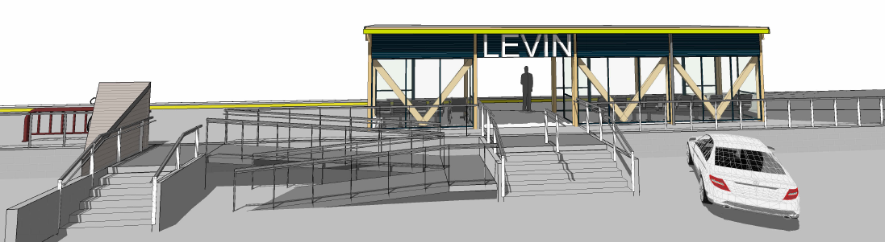

Delivery Schedule

Key Milestones | Key Dates
First Tūhono delivered to New Zealand: | mid 2028
First Tūhono achieves Provisional Acceptance & commences service on the Wairarapa Line | mid 2029
Tūhono trains commences service on the Manawatū line | early 2029
Last Tūhono achieves Provisional Acceptance | late 2030
Increased service frequency on the Wairarapa and Manawatū Line | late 2030

